

**Digital User Manual E-book**

**Product Requirements Document (PRD)**

***V2.0***

**Document Status:** Draft

**Document Type:** Product Requirements Document (PRD)

**Classification:** Confidential

**Department:** PD EESE

**Author: Geng Dekang**

|  |  |
| --- | --- |
| Reviewing Manager: |  |
| Document Location: |  |
| Date Released: | <Date the reviewing manager approved this document MM/DD> |

**Project: SYNC+**

Contents

1 Document overview 4

1.1 Document purpose 4

1.2 Document scope 4

2 General Assumptions 4

2.1 User 4

2.2 Vehicle 4

3 Requirement Demonstration 5

3.1 Description 5

3.1.1 Function Structure 5

3.1.2 Flow Chart（Please refer to appendix ） 7

3.1.3 User interface reference 7

3.2 Assumptions 8

3.3 User stories 9

3.4 User Requirements for 1.0 9

3.4.1 9

3.4.2 10

3.4.3 10

3.4.4 11

3.4.5 12

3.4.6 13

3.5 User Requirements for 2.0 13

3.5.1 Alarm light info 13

3.5.2 Multi-Manual 14

3.5.3 Two-way Jump 15

3.5.4 Tips &Videos 16

3.5.5 Hot Search 17

3.5.6 Audio Broadcast 18

3.5.7 VPA 19

3.5.8 Maintenance Records 19

3.5.9 Color Match 20

3.5.10 Voice Command Classification 20

4 Technical Upgrade 21

5 Classification Key 21

6 Document Status Key 21

7 Terms, Acronyms and Definitions 21

8 Changes 22

9 Contacts 22

10 Appendix 22

# Document overview

## Document purpose

This requirements document is intended to develop an E-Manual application which will be installed in Ford Vehicles’ IVI system. Under the circumstances, it will be displayed in a visible, intelligent, and quick way to drivers.

## Document scope

This requirement document serves as a guide to in-house team for E-Manual. The requirement is used for the HMI team to design the whole User Interface. This document is also an important reference document for test team for developing test case.

# General Assumptions

## User

The user is assumed responsible for:

* Customers can directly click the options which used frequently
* Customers can directly search the key words of functions to reach the detail
* Customers can directly click the spot of the vehicle picture to reach the function details
* Customers can directly search the key words of functions via intelligent voice recognition

## Vehicle

For a vehicle supporting entertainment feature, the vehicle must have all of the following:

* Intelligent voice recognition function should work well.
* The IVI system should work well with surrounding parts.
* TCUs have been activated and have internet access

# Requirement Demonstration

## Description

**Digital User Manual**：An android application for IVI system which is convenient for the customers to learn the detail of user manual. It includes all functions of vehicle, technical parameters of the vehicle and maintenance .etc. The screen is adaptive according to the size of display.

**Movie Service Provider**

**APK Entrance**：There are many options, such as vehicle setting, tool bar or main page icon(recommend) etc.

**Screen detail of each program**

|  |  |  |  |
| --- | --- | --- | --- |
| **Program** | **Screen** | **Size** | **resolution** |
| U540 |  |  |  |
| C519ICA |  |  |  |
| CD539ICA | Landscape | 13.2’’ | 2348*1080 |
| CX483ICA | Landscape | 12.8’’ | 1080*1920 |
| U611ICA | Landscape | 12.8’’ | 1080*1920 |
| U554 | Landscape | 13.2’’ |  |
| U725 | Landscape | 12’’ |  |
| CX727 | Portrait | 15.5’’ |  |
| CD542 Low | Landscape | 13.2’’ |  |
| CD542 High | Landscape | 27’’ |  |
| U625ICA | Landscape | 27’’ |  |
| P702 | Landscape | 12’’ |  |
| CD764 | Landscape | 27’’ |  |

### 3.1.1 Function Structure

|  |  |  |  |  |
| --- | --- | --- | --- | --- |
| **Module** | **Function** | **Sub-function** | **Description** | **Priority** |
| **Query** | By keyword |  |  | High |
| By VR |  |  | Medium |
| By history |  |  | High |
| Fuzzy query |  |  | High |
| **Button** | All | Sub-menu of all manuals | Content of all manuals | High |
| SYNC+ | Sub menu of SYNC+ Manual | Content of SYNC+ Manual |  |
| Media | Online/native videos | Tips & Videos |  |
| Maintenance | Sub menu of Maintenance Manual | Content of Maintenance menu | High |
| Symbol | Symbol Icon | Details of all symbols | Medium |
| **Picture**  **guide** | Picture rotate control | Front/Rear view | View switching | High |
| Picture switch control | Interior/Exterior | Page switching | High |
| Hot Spot | Name | Show function name | High |
| **Function**  **instruction** | Picture instruction |  |  | High |
| Text instruction |  |  | High |
| Audio instruction | Play/Pause |  | Medium |
| Video instruction | Play/Pause/Stop |  | Medium |
| Progress bar |  | to show play progress | Medium |
| Seek to time |  | You can locate that video progress to a time point. | Medium |
| browse history |  | The app will show the latest 10 functions you have checked | High |
| Hot Search |  | The app will show the Top 10 Hot-Search functions | Medium |
| **Index** | Show function detail |  | Tap a button, it will show the detail of that function. | High |
| Guide Page |  | When you open the APP after updating, it will guide you new function. | High |

### 3.1.2 Flow Chart（Please refer to appendix ）

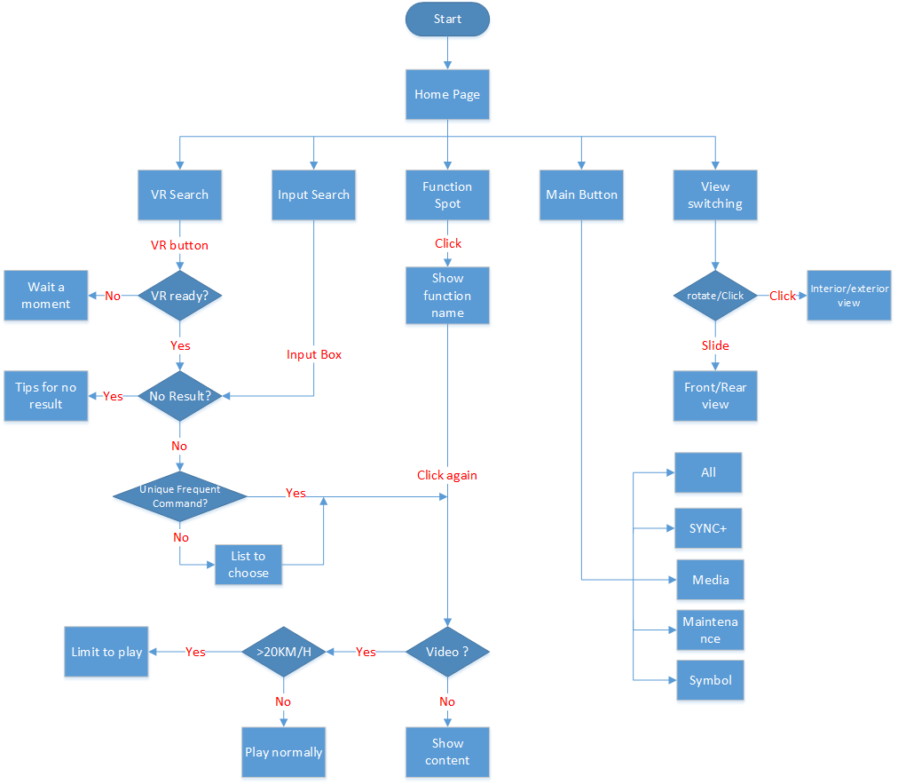

### 3.1.3 User interface reference

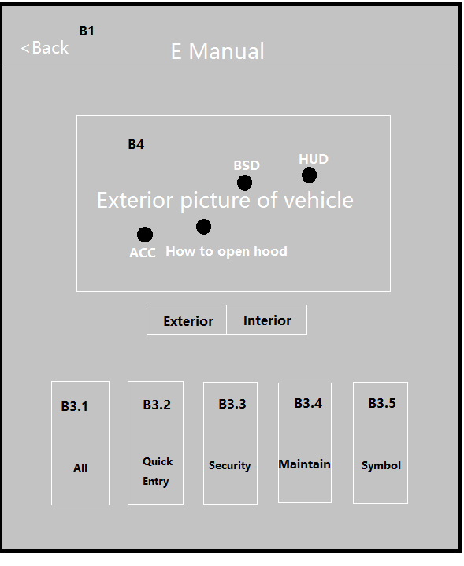

Figure (1) Main page reference

**B1**（Button 1）：Leave this APP

**B2**: choose the view of vehicle(Exterior/Interior)

**B3**: Choose the module of E-manual to browse

**B4**: Function Spot distributed on the vehicle picture

## Assumptions

* Intelligent voice recognition function should work well...
* The IVI system should work well with surrounding parts.
* TCUs have been activated and have internet access

## User stories

|  |  |
| --- | --- |
| **User Story ID** | **User Story** |
| Digital User Manual | As a driver/passenger of Ford vehicle, I want to know some functions’ instructions and how to use them. |

## User Requirements for 1.0

|  |  |
| --- | --- |
| Use Case ID | 3.4.1 |
| Use Case | 1. As a customer, I want to learn how to use this App at the beginning 2. As a customer, I want to Know the new function introduction after updating software |
| Pre-Conditions | 1. IVI is running 2. APP is working |
| Trigger | The user selects and clicks the “E-manual” icon on the main menu. |
| Expected Behavior | 1. The user can learn the skills from the User Guide. 2. The user can get the new feature introduction when first clicking updated software. |
| Post Conditions | Digital User Manual should be updated on time. |
| Exceptions | If there is any event which has higher priority comes in, it will be terminated or performed in the background. |

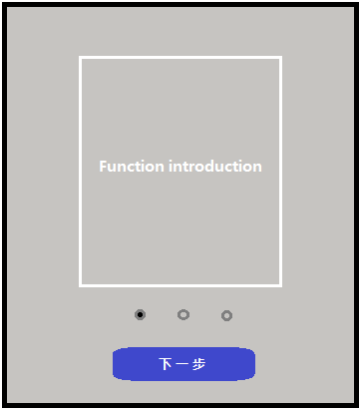 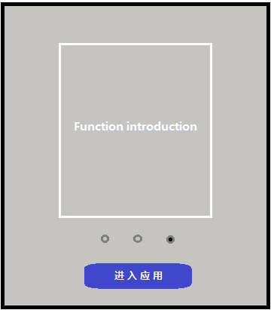

Example of 3.4.1

|  |  |
| --- | --- |
| Use Case ID | 3.4.2 |
| Use Case | As a customer, I want to find the guide of frequently used functions quickly |
| Pre-Conditions | 1. IVI is running 2. APP is working |
| Trigger | The user selects and clicks the “B3.1-Quick Entry” on the main page of APP. |
| Expected Behavior | The user can directly click the options, which used frequently, and it will turn to the detail. |
| Post Conditions | Digital User Manual should be updated on time. |
| Exceptions | If there is any event which has higher priority comes in, it will be terminated or performed in the background. |

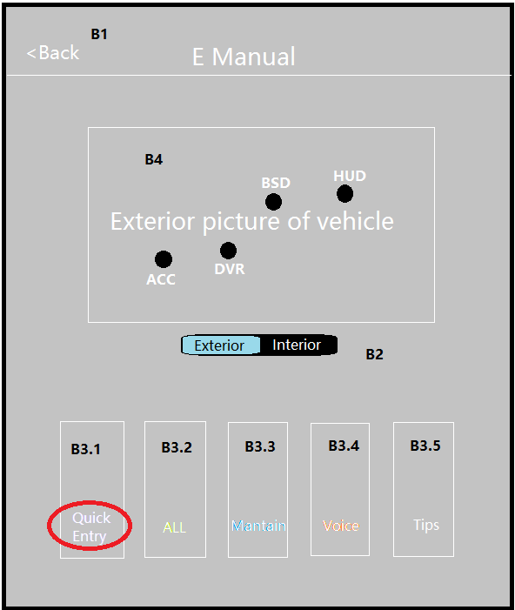 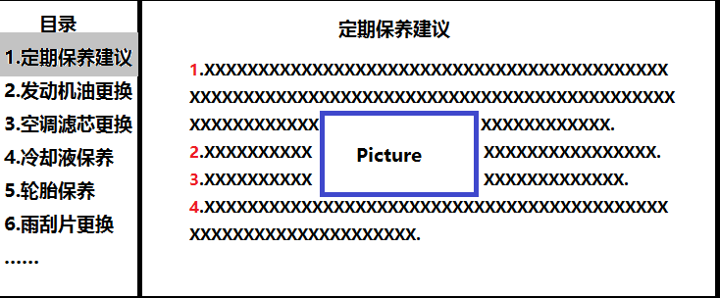

Example of 3.4.2

|  |  |
| --- | --- |
| Use Case ID | 3.4.3 |
| Use Case | As a customer, I want to search any function which I am interested in. |
| Pre-Conditions | 1. IVI is running 2. APP is working |
| Trigger | The user selects and clicks the “Search” area on the main page of APP. |
| Expected Behavior | The user can directly search the key words of functions to reach the detail |
| Post Conditions | Digital User Manual should be updated on time. |
| Exceptions | If there is any event which has higher priority comes in, it will be terminated or performed in the background. |

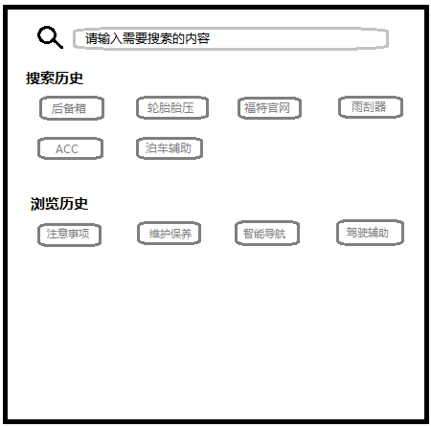

Example of 3.4.3

|  |  |
| --- | --- |
| Use Case ID | 3.4.4 |
| Use Case | As a customer, I want to locate the position where I Searched and browsed last time. |
| Pre-Conditions | 1. IVI is running 2. APP is working |
| Trigger | The user clicks the “search” column and then see the search and browse history below. |
| Expected Behavior | It will turn to the target page according to what the user says |
| Post Conditions | Digital User Manual should be updated on time. |
| Exceptions | If there is any event which has higher priority comes in, the searching will be terminated or performed in the background. |



Example of 3.4.4

|  |  |
| --- | --- |
| Use Case ID | 3.4.5 |
| Use Case | As a customer, I want to know the meaning of warning indicator light. |
| Pre-Conditions | 1. IVI is running 2. APP is working 3. CAN network works well |
| Trigger | The user clicks the “B2-symbol” icon ,then click the corresponding indicator light |
| Expected Behavior | It will turn to the introduction page, includes name, reason and how to repair it. |
| Post Conditions | Digital User Manual should be updated on time. |
| Exceptions | If there is any event which has higher priority comes in, it will be terminated or performed in the background. |

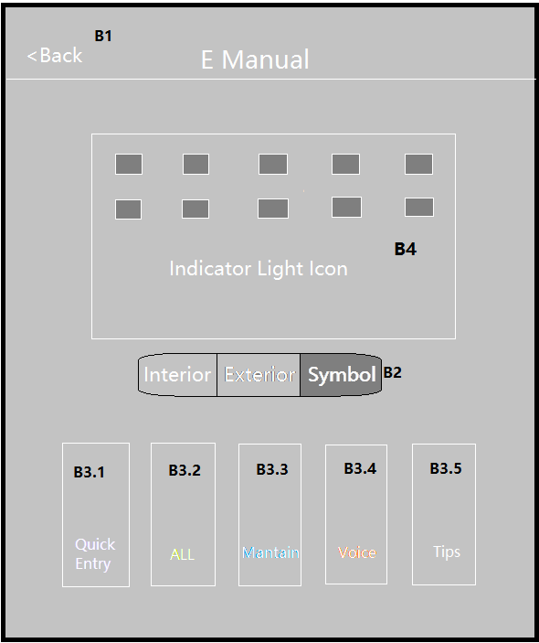 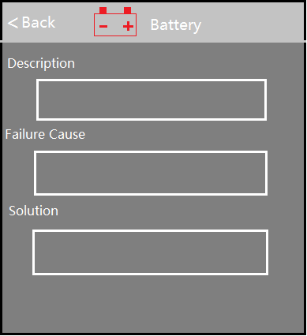

Example of 3.4.5

|  |  |
| --- | --- |
| Use Case ID | 3.4.6 |
| Use Case | As a customer, I want to learn new functions introduction after OTA updating |
| Pre-Conditions | 1. ACC/Ignition on 2. APP works well |
| Trigger | 1. The user clicks “P3” 2. Press “VR” button, then say “new function/updated logs” |
| Expected Behavior | It will turn to the introduction page. |
| Post Conditions | Digital User Manual should be updated on time. |
| Exceptions | Pop-up occurs at the first time IVI powered on after OTA. If there is any event which has higher priority comes in, it will be terminated or performed in the background. |

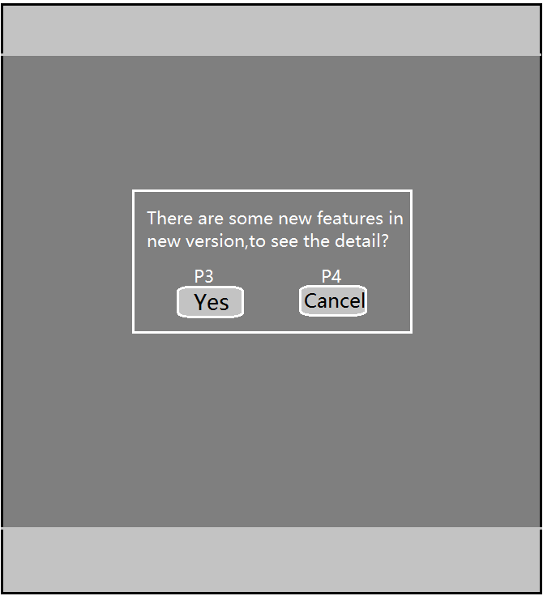 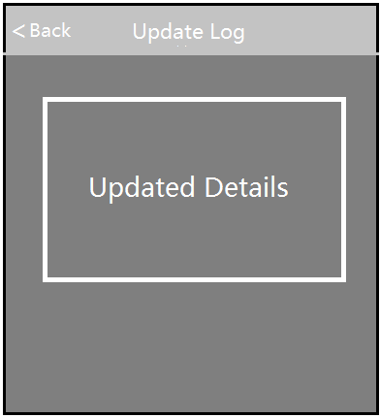

Example of 3.4.6

## User Requirements for 2.0

|  |  |
| --- | --- |
| Use Case ID | 3.5.1 Alarm light info |
| Use Case | As a customer, I want to obtain detailed warning information when the alarm light on IPC flashing. |
| Pre-Conditions | 1. ACC/Ignition on 2. CAN network works well |
| Trigger | 1. The user clicks the E-manual icon of VHA’s pop-up page . 2. The user presses “VR” button, then say “alarm light” |
| Expected Behavior | It will turn to the introduction page, includes name, reason and how to repair it. |
| Post Conditions | Digital User Manual should be updated on time. |
| Exceptions | 1) The action that IVI system takes to remind drivers belongs to IVI system layer  design, E-manual book application only provides the interface.  2) The quantity of supported alarm light depends on VHA feature |

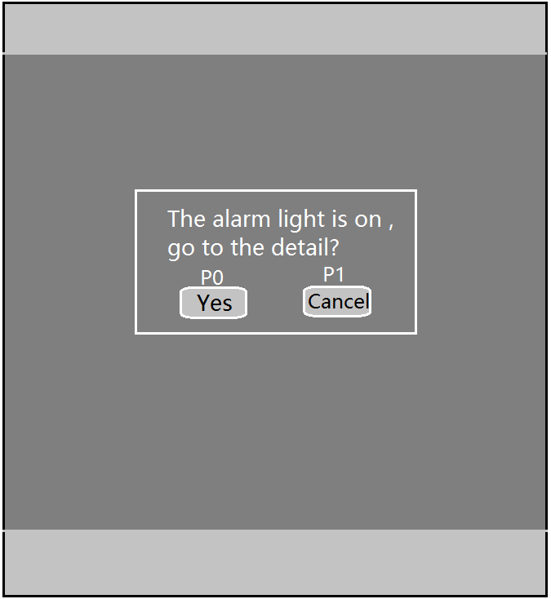 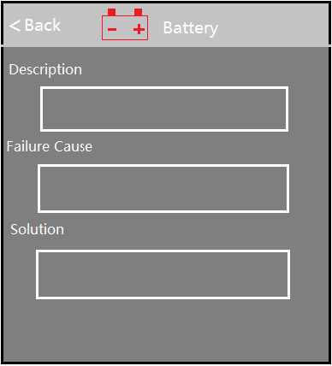

Example of 3.5.1

|  |  |
| --- | --- |
| Use Case ID | 3.5.2 Multi-Manual |
| Use Case | As a customer, I want to find every manual in E-Manual Book App. |
| Pre-Conditions | 1. ACC/Ignition on 2. APP works well |
| Trigger | The user clicks “B3.1-B3.5” |
| Expected Behavior | It will turn to “OM”,” SYNC+”,” Multi-Media”,” Maintain”,” Symbol” introduction page. |
| Post Conditions | Digital User Manual should be updated on time. |
| Exceptions | Pop-up occurs at the first time IVI powered on after OTA. If there is any event which has higher priority comes in, it will be terminated or performed in the background. |

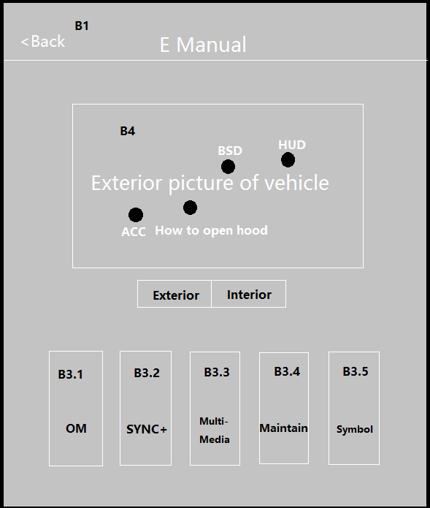

Example of 3.5.2

**B3.1**：Owner’s Manual

**B3.2**: SYNC+ Manual

**B3.3**: Multi-Media Manual

**B3.4**: Maintenance Manual

**B3.5**: Symbol

|  |  |
| --- | --- |
| Use Case ID | 3.5.3 Two-way Jump |
| Use Case | As a customer, I want to Jump directly to the relevant Settings page. |
| Pre-Conditions | 1. IVI is running 2. APP is working |
| Trigger | 1. The user clicks the “C1” button 2. The user clicks the “C2” button |
| Expected Behavior | 1. After clicking C1 button, it should jump into setting page 2. After clicking C2 button, it should jump back into E-manual page |
| Post Conditions | Digital User Manual should be updated on time. |
| Exceptions | If there is any event which has higher priority comes in, it will be terminated or performed in the background. |

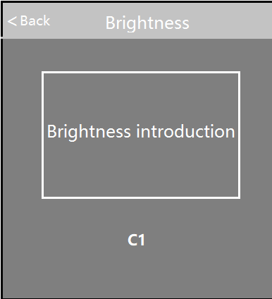 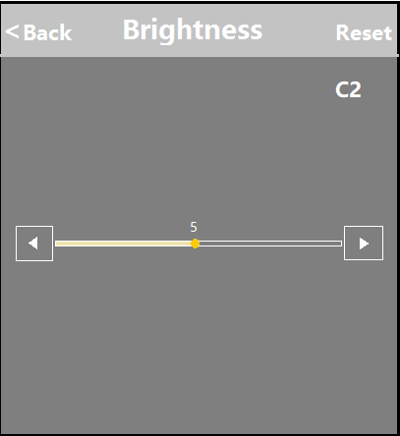

Example of 3.5.3

**C1**：E-manual jump into setting page

**C2**: Setting page jump back into E-manual

|  |  |
| --- | --- |
| Use Case ID | 3.5.4 Tips &Videos |
| Use Case | As a customer, I want to learn some complex functions via video |
| Pre-Conditions | 1. ACC/Ignition on 2. APP works well |
| Trigger | 1. The user clicks “B3.3” 2. Press “VR” button, then say “xxxx video” |
| Expected Behavior | It will turn to the “Tips & Videos” page. |
| Post Conditions | Digital User Manual should be updated on time. |
| Exceptions | Pop-up occurs at the first time IVI powered on after OTA. If there is any event which has higher priority comes in, it will be terminated or performed in the background. |

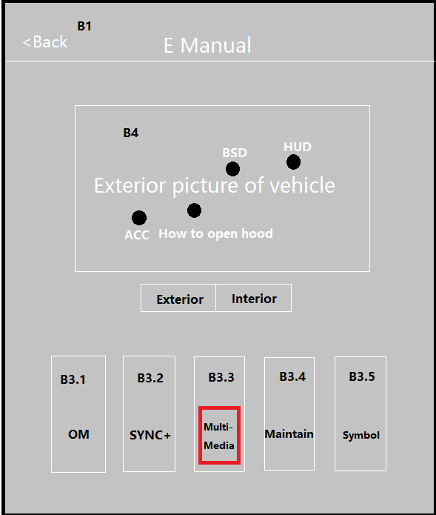 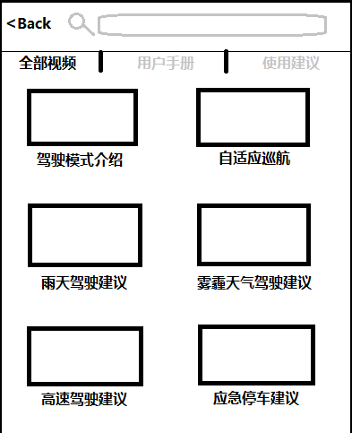

Example of 3.5.4

|  |  |
| --- | --- |
| Use Case ID | 3.5.5 Hot Search |
| Use Case | As a customer, I want to see the hot search rank and then help me to make a choice. |
| Pre-Conditions | 1. IVI is running 2. APP is working |
| Trigger | The user clicks the “Hot Search” column and click the term they interest in |
| Expected Behavior | It will turn to the target page according to what the user clicks |
| Post Conditions | Digital User Manual should be updated on time. |
| Exceptions | If there is any event which has higher priority comes in, the searching will be terminated or performed in the background. |

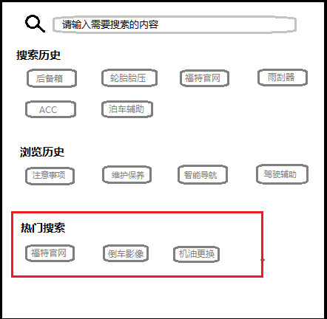

Example of 3.5.5

|  |  |
| --- | --- |
| Use Case ID | 3.5.6 Audio Broadcast |
| Use Case | As a customer, I want to listen to the broadcast of content when I am driving a car. |
| Pre-Conditions | 1. IVI is running 2. APP is working |
| Trigger | The user clicks the “C3” |
| Expected Behavior | The part of content will be broadcasted with human voice. |
| Post Conditions | 1. Digital User Manual should be updated on time. 2. The user can choose different kind of human voice in setting page. |
| Exceptions | If there is any event which has higher priority comes in, it will be terminated or performed in the background. |

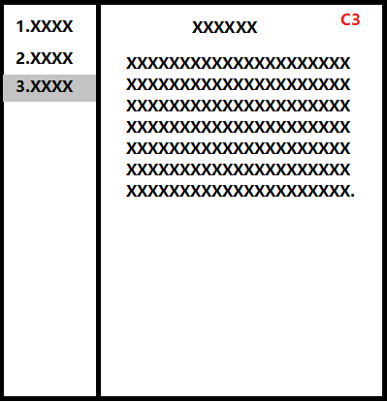

Example of 3.4.4

**C1**:back to previous step

**C2&C3**:Pause or Play

**C4**:Fast forward or Fast rewind

|  |  |
| --- | --- |
| Use Case ID | 3.5.7 VPA |
| Use Case | As a customer, I want to search the function via VR when I am driving. |
| Pre-Conditions | 1. IVI is running 2. APP is working |
| Trigger | The user clicks the “VR” button on the steering wheel or waking up the voice by “wake-up words”. |
| Expected Behavior | It will have a dialogue with the user to find user’s requirement. |
| Post Conditions | Digital User Manual should be updated on time. |
| Exceptions | If there is any event which has higher priority comes in, VR function will be terminated or performed in the background. |

|  |  |
| --- | --- |
| Use Case ID | 3.5.8 Maintenance Records |
| Use Case | As a customer, I want to find my maintenance record from IVI system |
| Pre-Conditions | 1. IVI is running 2. APP is working |
| Trigger | The user clicks the “VR” button on the steering wheel or waking up the voice by “wake-up words”. |
| Expected Behavior | It will have a dialogue with the user to find user’s requirement. |
| Post Conditions | Digital User Manual should be updated on time. |
| Exceptions | If there is any event which has higher priority comes in, VR function will be terminated or performed in the background. |

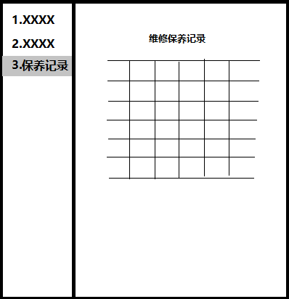

Example of 3.5.8

|  |  |
| --- | --- |
| Use Case ID | 3.5.9 Color Match |
| Use Case | As a customer, I want the picture of display to match with my entity vehicle, including color and model. |
| Pre-Conditions | 1. IVI is running 2. APP is working |
| Trigger | The user clicks “E-Manual” icon of IVI system |
| Expected Behavior | The vehicle picture in the home page should match with entity vehicle. |
| Post Conditions | Digital User Manual should be updated on time. |
| Exceptions | If there is any event which has higher priority comes in, VR function will be terminated or performed in the background. |

|  |  |
| --- | --- |
| Use Case ID | 3.5.10 Voice Command Classification |
| Use Case | As a customer，   1. I want to jump into the introduction page directly after I say the voice command which is unique. 2. I want to jump into search result page to let me choose the correct chapter after I say the voice command which is not unique. |
| Pre-Conditions | 1. IVI is running 2. APP is working |
| Trigger | 1. The User says “Unique Frequent Voice commands” 2. The User says “other commands” |
| Expected Behavior | 1. It should jump into the introduction page directly after the user says the unique frequent voice command 2. It should jump into the search result page after the user says the rest of voice command |
| Post Conditions | 1. Digital User Manual should be updated on time. 2. Voice Command list in appendix should be updated on time. |
| Exceptions | If there is any event which has higher priority comes in, VR function will be terminated or performed in the background. |

# Technical Upgrade

|  |  |  |
| --- | --- | --- |
| **Num** | **Title** | **Description** |
| **4.1** | Collect User Data | Collect users’ clicking event and voice command from backend. |
| **4.2** | Cloud incremental upgrade | Per the content needs to be updated, make them incremental update via Cloud |
| **4.3** | Vehicle oriented upgrade | Per the update requirement of vehicle, only upgrade partly vehicle we need. |
| **4.4** | Online offline switch | User can choose online view via cloud or offline view. |
| **4.5** | Synonym mapping | Mapping related synonym |
| **4.6** | Support Hot-Fix |  |
| **4.7** | Proper videos’ length | To keep user’s patience, make videos’ length proper |

# Classification Key

|  |  |
| --- | --- |
| **Classification** | **Notes** |
| Proprietary | Information created or obtained in the normal course of business and not classified as Secret or Confidential |
| Confidential | Information that provides the Company with a competitive advantage, that supports its technical or financial position, and which, if disclosed without authorization, could cause damage to the Company. |
| Secret | Information of a strategic or highly sensitive nature that, if disclosed without authorization, would cause substantial, severe, or irreparable damage to the Company or its relationships. |

# Document Status Key

|  |  |
| --- | --- |
| **Status** | **Notes** |
| DRAFT | Document currently being worked on. Shall not be used as a solid reference to information included in this document. |
| AFR | Available For Review. Document information is not eligible for changes. Approving manager will revise this document and if all the information is found to be completely valid, then the document will change to REL status. If the document is found to have errors, the document will change to DRAFT status. |
| REL | Released. Document is completely valid at time of review, and is now available to be used as a solid reference of information. |

# Terms, Acronyms and Definitions

|  |  |
| --- | --- |
| **Term or Acronym** | **Definition** |
| IVI | In-vehicle infotainment |
| TCU | Telematics Control Unit |
| VR | Voice Recognition |
| TTS | Text to Speech |
| VHA |  |

# Changes

|  |  |  |  |
| --- | --- | --- | --- |
| **Author** | **Date (YYYY/MM/DD)** | **Status** | **Notes** |
| Geng Dekang | 2020/02/11 | DRAFT | Version 1.0 - Initial draft at compiling all use cases, available information and existing requirements |
|  |  |  |  |
|  |  |  |  |
|  |  |  |  |
|  |  |  |  |
|  |  |  |  |
|  |  |  |  |
|  |  |  |  |

# Contacts

For assistance or correction, please contact any of the following:

Geng Dekang

AP SYNC System Engineer

E-mail: dgeng1@ford.com

# Appendix

